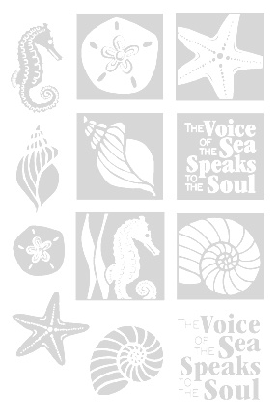
2011 SUMMER RENDEZVOUS

The New York Sail and Power Squadron is hosting its annual Summer Rendezvous and Barbecue on Saturday August 27th, 2011 at Miramar Yacht Club in Sheepshead Bay in Brooklyn.

The festivities begin at 1700 (5:00pm)

This is a great opportunity to visit with each other, meet old friends and new friends and visit with the members of Miramar Yacht Club.

RSVP BY 24 AUGUST 2011 so that we know who is coming and have enough BBQ food (vegetarian included) and libations.

- The event is $15 per person.
- Those who are coming by boat may pick up moorings for $40, which includes launch service and overnight stay.

To reserve your seat, return the completed tear-off form below by August 24th or email your RSVP to: G. Manjorin: 201 Emerson Place, Valley Stream, NY 11580 phone: 516-825-5899 email: GManjorin@aol.com

If you RSVP by mail please include a check. Checks will also be accepted at the BBQ but you must RSVP in advance.

-------------------------------------------------------------------------------------------------------------------
Reservations for Summer Rendezvous, Saturday August 27th 2011

I/We will attend. Enclosed is $___________ for #___________ persons

Name ______________________________________________________________

Guests ______________________________________________________________

_____________________________________________________________________

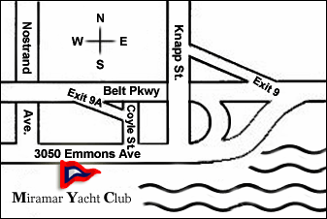
DIRECTIONS To Miramar Yacht Club
(MYC VHF channel 68)
By Car:
From Manhattan & Downtown Brooklyn
Belt Parkway Eastbound to Knapp Street Exit 9A.
Right turn on Coyle Street to Emmons Avenue, right turn -
4 blocks to Miramar.
From Queens & Long Island
Belt Parkway westbound to Knapp Street Exit 9.
Left turn on Knapp Street to Emmons Avenue, right turn -
7 blocks to Miramar.
From New Jersey South
Goethals Bridge -> Verrazano Bridge -> Belt Parkway eastbound.
Follow directions from Manhattan & Downtown Brooklyn.
From New Jersey North
George Washington Bridge -> Major Deegan Expressway ->
Triboro Bridge -> Grand Central Parkway -> Van Wyck Expressway ->
Belt Parkway Brooklyn.
Follow directions from Queens & Long Island.
L 40°34.986’N
λ 073°56.221’W
Miramar YC is located just north of Nun16 in Sheepshead Bay (Below)

Stay clear of Can 7 Sheepshead Bay Channel if near low water! Shoaling has been reported between Sheepshead Bay Lighted Buoy 6 (LLNR 34550) and Sheepshead Bay Buoy 8 (LLNR 3465). Use caution when transiting the area.
From Central Brooklyn
Ocean Avenue -> left on Emmons Avenue -> pass Nostrand Avenue. 1/2 block, right side to Miramar.
By Bus:
B-44 Nostrand Avenue -> Walk one block to Emmons Avenue -> 3050 MYC.
By Train:
Q Local or B Express train to Sheepshead Bay Road Station.
Transfer and take the B-4 bus on Avenue Z East 16 > Nostrand Avenue stop >
Walk one block to Emmons Avenue > 3050 MYC.
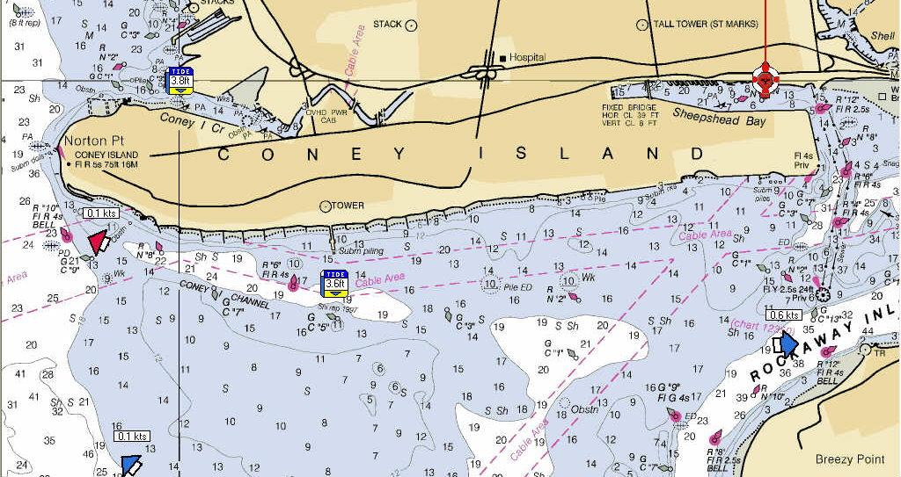
From the Sea:
Rockaway Inlet Channel at Breezy Point
to Sheepshead Bay Channel
into Sheepshead Bay
From the Hudson River:
Hudson River to
Coney Island Channel at Nortons Point
to Sheepshead Bay Channel
into Sheepshead Bay
Miramar Yacht club can be reached
on VHF channel 68.

